5.NBT.B.6: Divide Whole Numbers with 4 Digit Dividends and 2 Digit Divisors

**Target Grade Level:** 5th

**Common Core Domain:** Numbers and Operations Base Ten

**Common Core Cluster:** Perform Operations with Multi-Digit Numbers and with Decimals to Hundredths

**Standard (with text below): 5.NBT.B.6**

Find whole-number quotients of whole numbers with up to four-digit dividends and two-digit divisors, using strategies based on place value, the properties of operations, and/or the relationship between multiplication and division. Illustrate and explain the calculation by using equations, rectangular arrays, and/or area models.

**MAIN CONCEPTS**

* Solve whole number division problems with whole-number quotients with up to four-digits and two-digit divisors, using strategies based on place value.
* Solve whole number division problems with whole-number quotients with up to four-digits and two-digit divisors, using strategies based on the properties of operations.
* Solve whole number division problems with whole-number quotients with up to four-digits and two-digit divisors, using strategies based on the relationship between multiplication and division.

**Clarifications, limits, emphases, and other information intended to ensure**

**appropriate variety in tasks**

* Problems involve whole numbers with 3- or 4-digit dividends and one- or two-digit divisors with whole number quotients.
* Illustrate and explain calculations using equations, rectangular arrays, and or area models.
* Avoid the use of the standard algorithm.

**About the Math**

Area Model

l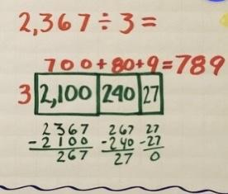

Dividing using the distributive property

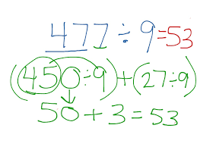

**Relationship to Mathematical Practices**

* .[CCSS.MP7](http://static.pdesas.org/content/documents/bulleted_mathematical_practices.pdf) Look for and make use of structure

**Additional Resources:**

* [IXL](https://www.ixl.com/standards/common-core/math/grade-5) – see main concepts and hover over each to see example problems
* <https://tasks.illustrativemathematics.org/content-standards/5/NBT/B/6?gclid=Cj0KCQiA4aacBhCUARIsAI55maHMmxkSwh2SK9XcHVlhGnRzwP50L-ZFylDwPbdR90CblXCrKQnJ4i4aApssEALw_wcB>
* <https://kera.pbslearningmedia.org/resource/2829430e-d445-4048-be89-7a785d6d0cf4/number-and-operations-in-base-10-grade-5-5nbtb6-5nbtb7/>